

**User Research Outcomes**

**LAB SHEET 4**

**M.P.P.Shamil | IT17018760 | SE3050 - UEE**

# Task 4 :Wireframe 1

#### User comments

* Labels and text boxes are not in common places.
* Users can’t find the way to delete medicine items on the list.
* Save, edit icons are hard to find.
* Doctor can see only appointment date firstly.

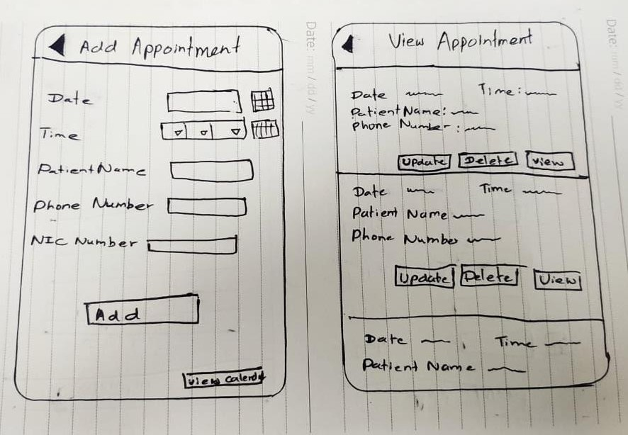**Wireframe 2**

User comments

* There is back button to go to previous page.
* Save, edit buttons are easy to find.
* Doctor can see the appointment details
* Doctor can easily delete items off the list.

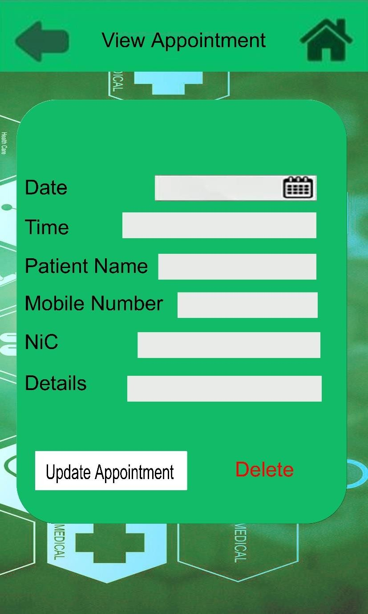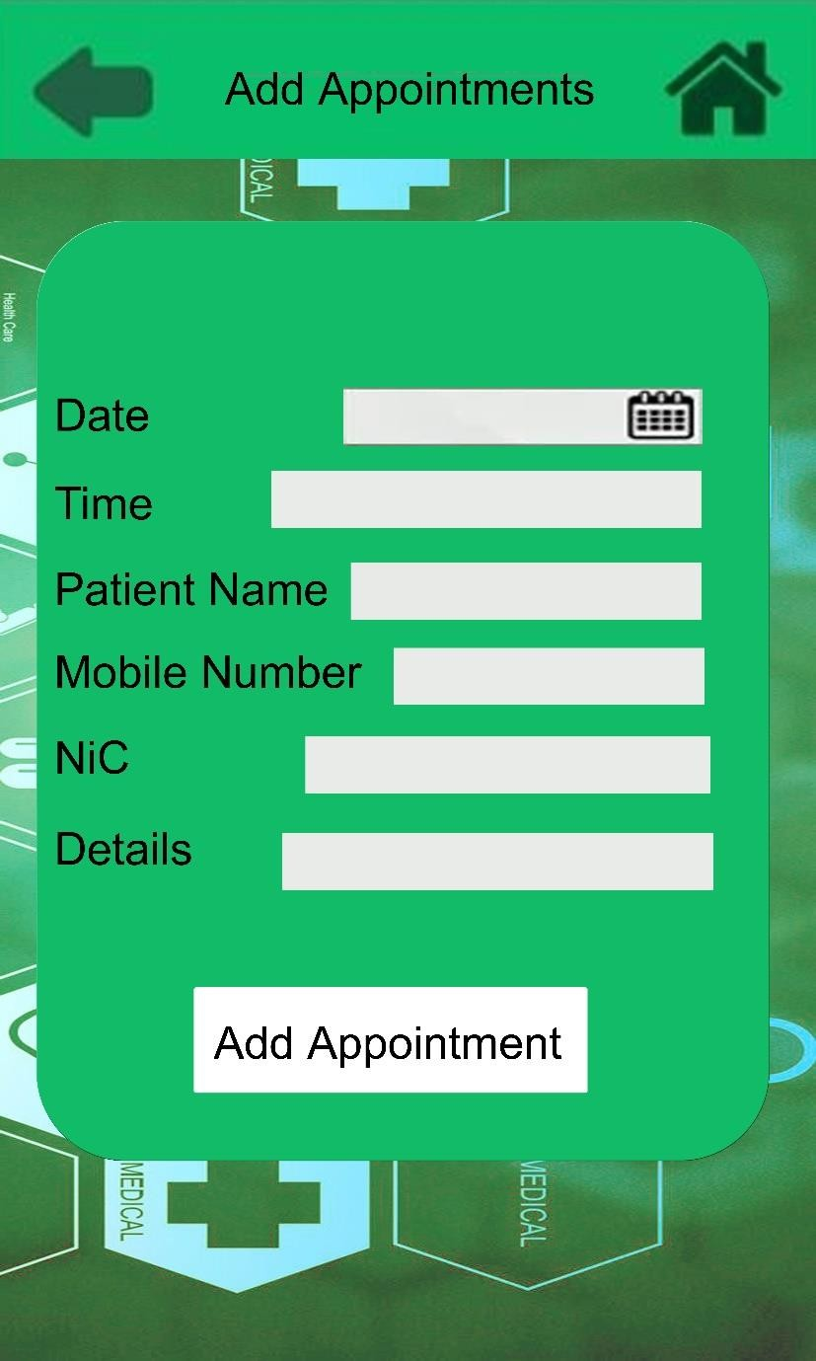

M.P.P.Shamil | IT17018

**Task 4:Adobe XD design**



